UNITED STATES
SECURITIES AND EXCHANGE COMMISSION
Washington, D.C. 20549

FORM 8-K

CURRENT REPORT

Pursuant to Section 13 or 15(d) of the Securities Exchange Act of 1934

Date of Report (Date of earliest event Reported): September 11, 2026

Scholar Rock Holding Corporation
(Exact Name of Registrant as Specified in Charter)

Delaware | 001-38501 | 82-3750435
(State or Other Jurisdiction of  Incorporation) | (Commission File Number) | (I.R.S. Employer Identification Number)
301 Binney Street, 3rd Floor, Cambridge, MA 02142
(Address of Principal Executive Offices) (Zip Code)

(857) 259-3860
(Registrant's telephone number, including area code)

(Former name or former address, if changed since last report)

Check the appropriate box below if the Form 8-K filing is intended to simultaneously satisfy the filing obligation of the registrant under any of the following provisions:

☐ | Written communications pursuant to Rule 425 under the Securities Act (17 CFR 230.425)
☐ | Soliciting material pursuant to Rule 14a-12 under the Exchange Act (17 CFR 240.14a-12)
☐ | Pre-commencement communications pursuant to Rule 14d-2(b) under the Exchange Act (17 CFR 240.14d-2(b))
☐ | Pre-commencement communications pursuant to Rule 13e-4(c) under the Exchange Act (17 CFR 240.13e-4(c))

Securities registered pursuant to Section 12(b) of the Act:

Title of each class | Trading Symbol(s) | Name of each exchange on which registered
Common Stock, par value $0.001 per share | SRRK | The Nasdaq Global Select Market

Indicate by check mark whether the registrant is an emerging growth company as defined in Rule 405 of the Securities Act of 1933 (17 CFR §230.405) or Rule 12b-2 of the Securities Exchange Act of 1934 (17 CFR §240.12b-2). Emerging growth company ☐

If an emerging growth company, indicate by check mark if the registrant has elected not to use the extended transition period for complying with any new or revised financial accounting standards provided pursuant to Section 13(a) of the Exchange Act. ☐

Item 7.01. Regulation FD Disclosure.

On September 11, 2026, Scholar Rock Holding Corporation (the “Company”) issued a press release announcing that the U.S. Food and Drug Administration (“FDA”) has approved ISEMBYLD™ (apitegromab-mstn) for the treatment of spinal muscular atrophy (SMA) in adults and children 2 years of age and older who are currently receiving a survival motor neuron 2 (SMN2) targeted treatment. A copy of the press release is furnished as Exhibit 99.1 to this Current Report on Form 8-K and is incorporated herein by reference. A copy of the Company’s presentation materials in connection with the announcement is furnished as Exhibit 99.2 to this Current Report on Form 8-K and is incorporated herein by reference. The Company will host a webcast and conference call on September 14, 2026 at 8:00 a.m. Eastern Time to discuss the approval, during which management will review the presentation materials furnished as Exhibit 99.2.

The information in Item 7.01 of this Form 8-K, including Exhibits 99.1 and 99.2, shall not be deemed “filed” for purposes of Section 18 of the Securities Exchange Act of 1934, as amended (the “Exchange Act”), or otherwise subject to the liabilities of that section, nor shall it be deemed incorporated by reference in any filing under the Securities Act of 1933, as amended, or the Exchange Act, except as expressly set forth by specific reference in such a filing.

Item 8.01. Other Events.

On September 11, 2026, the Company announced that the FDA has approved ISEMBYLD™ (apitegromab-mstn) for the treatment of SMA in adults and children 2 years of age and older who are currently receiving a survival SMN2 targeted treatment.

Item 9.01. Financial Statements and Exhibits.

(d) Exhibits

Exhibit  No. |  | Description
99.1 |  | Press Release issued by the Company on September 11, 2026, furnished hereto.
99.2 |  | Presentation Slides, furnished hereto.
104 |  | Cover Page Interactive Data File (embedded within the Inline XBRL document)

SIGNATURE

Pursuant to the requirements of the Securities Exchange Act of 1934, the registrant has duly caused this report to be signed on its behalf by the undersigned hereunto duly authorized.

 | Scholar Rock Holding Corporation
Date: September 14, 2026 | By: | /s/ Junlin Ho
 |  | Junlin Ho
 |  | General Counsel & Corporate Secretary

Exhibit 99.1



Scholar Rock Announces FDA Approval of ISEMBYLD™ (apitegromab-mstn), the First and Only Muscle-Targeted Treatment for Children and Adults with Spinal Muscular Atrophy (SMA)

September 11, 2026

 | • | ISEMBYLD is approved for use in all adults and children ≥2 years of age with SMA who are currently receiving a survival motor neuron 2 (SMN2)-targeted treatment

 | • | ISEMBYLD recommended dose of 10 mg/kg showed a robust, clinically meaningful 2.2-point improvement in motor function as measured by the gold-standard Hammersmith Functional Motor Scale-Expanded (HFMSE) compared to placebo, with all patients receiving SMN2-targeted background therapy (p = 0.0121*)

 | • | ISEMBYLD showed a ≥ 3-point increase in HFMSE in 34.2% of patients compared to 13.5% of patients on placebo (odds ratio 3.8; p = 0.0125*)

 | • | ISEMBYLD U.S. commercial launch underway with product available to ship in the coming days; Scholar Rock Supports™ dedicated support team now available to assist patients and caregivers

 | • | Management to host investor call Monday, September 14, 2026, at 8:00 a.m. ET

* nominal p-value

CAMBRIDGE, Mass.--(BUSINESS WIRE)--Sep. 11, 2026-- Scholar Rock (NASDAQ: SRRK), a global biopharmaceutical company dedicated to improving the lives of patients with rare, severe, and debilitating neuromuscular diseases by applying its leading platform in myostatin biology, today announced that the FDA has approved ISEMBYLD (apitegromab-mstn) for the treatment of spinal muscular atrophy (SMA) in adults and children two years of age and older who are currently receiving a survival motor neuron 2 (SMN2)-targeted treatment.

SMA is a rare, severe neuromuscular disease that results in irreversible loss of motor neurons and progressive muscle wasting, causing continuous motor function decline throughout life and diminishing the independence of both adults and children.

ISEMBYLD is the first and only muscle-targeted treatment to demonstrate motor function improvement in individuals with SMA currently receiving an SMN2-targeted treatment. In the Phase 3 randomized, placebo-controlled SAPPHIRE study, individuals receiving ISEMBYLD demonstrated a robust, clinically meaningful improvement in motor function after one year of treatment while those on an SMN2-targeted treatment alone experienced a loss of motor function.

“Today’s FDA approval of ISEMBYLD marks a defining moment for the SMA community as we now launch the world’s first-ever muscle targeted treatment for children and adults living with SMA in the U.S.,” said David L. Hallal, Chairman and Chief Executive Officer of Scholar Rock. “After decades of failed industry-wide efforts to unlock the potential of myostatin inhibition, Scholar Rock has delivered a therapeutic breakthrough with ISEMBYLD. Our U.S. commercial team is now engaging physicians, SMA care teams, and payers on behalf of the SMA community and our Scholar Rock Supports™ team stands ready to provide dedicated, comprehensive assistance to patients and caregivers. I would like to extend my deepest thanks to our clinical study investigators, Cure SMA, and other patient advocacy groups for their dedication and support on this journey. Above all, I want to express my heartfelt gratitude to the patients and families affected by SMA who participated in our clinical trials for their trust in Scholar Rock and unwavering resilience every step of the way.”

“The approval of ISEMBYLD as the first-ever treatment to directly target the muscular component of SMA is a significant turning point for adults and children who have been waiting for innovative therapeutic options to improve motor function,” said Kenneth Hobby, President of Cure SMA. “We appreciate the FDA’s recognition, as reflected in this approval that supports access for a broad population within the SMA community, that improving motor function is a significant unmet need that must be addressed with urgency. Such improvements are fundamental to maintaining independence and to enabling participation in important activities of daily living from self-care to work and social interactions.”

With the approval of ISEMBYLD, Scholar Rock was awarded a Rare Pediatric Disease Priority Review Voucher, which may be used to obtain priority review for a future marketing application.

ISEMBYLD Robust Clinical Efficacy and Safety Profile from Phase 3 SAPPHIRE Study

The approval of ISEMBYLD was based on positive results from the Phase 3 pivotal, randomized, double-blind, placebo-controlled SAPPHIRE study. The SAPPHIRE study met its primary endpoint, and demonstrated a robust, clinically meaningful 2.2-point improvement in the gold-standard Hammersmith Functional Motor Scale-Expanded (HFMSE) in patients receiving ISEMBYLD 10 mg/kg and an SMN2-targeted treatment compared to patients receiving an SMN2-targeted treatment alone at one year (nominal p= 0.0121; main efficacy population 2 - 12 years of age, n = 103). Additionally, 34.2% of ISEMBYLD-treated patients showed a ≥ 3-point increase in HFMSE compared to 13.5% of placebo-treated patients (odds ratio of 3.8; nominal p = 0.0125).

ISEMBYLD has a well-characterized safety profile. The safety database includes more than 500 individuals across all apitegromab clinical studies globally, some of whom have been on treatment for more than 7 years. Ninety-eight percent of participants treated in SAPPHIRE elected to continue in the ONYX long-term extension study. In the SAPPHIRE study, the most common adverse reactions were upper respiratory tract infections, vomiting, cough, other viral infections, headache, gastroenteritis, pharyngitis, and hypersensitivity. Fractures occurred in 9% of patients treated with ISEMBYLD 10 mg/kg vs. 2% in placebo.

For further information, see Important Safety Information below.

“Today’s approval of ISEMBYLD marks a new era for the treatment of SMA,” said Dr. Basil Darras, M.D., Associate Neurologist-in-Chief, Director of the Neuromuscular Center and Spinal Muscular Atrophy Program at Boston Children’s Hospital, and a principal investigator in the SAPPHIRE study. “As neurologists, families consistently tell us that their top priority is gaining motor function, and we are now able to directly target the muscle, not just the motor neuron, for people living with SMA.”

ISEMBYLD Commercial Availability and Patient Access

Scholar Rock Supports is now available to assist patients who have been prescribed ISEMBYLD. This program is designed to provide personalized support for patients and families, and includes help to understand insurance coverage, financial assistance programs for eligible patients, and disease and treatment education. Scholar Rock Supports will also help patients and families navigate their site of care options, as well as ongoing infusion logistics. Based on eligibility, infusions can be given at convenient locations including hospital, home, or infusion center. ISEMBYLD will be available to ship in the coming days.

Scholar Rock is working closely with top commercial and government payers to establish reliable, broad access to ISEMBYLD for appropriate patients.

Healthcare providers and patients can learn more about Scholar Rock’s patient support services by visiting www.ScholarRockSupports.com or calling 833-777-5444 (833-SRRK-444). For more information about ISEMBYLD and U.S. Prescribing Information, visit www.ISEMBYLD.com.

Conference Call Information

Scholar Rock will host a conference call and webcast on Monday, September 14, 2026, at 8:00 a.m. ET. To access the live audio webcast, please go to “Events and Presentations” in the Investors section of the Scholar Rock website at https://investors.scholarrock.com.

To participate via telephone, please register in advance here. Upon registration, all telephone participants will receive a confirmation email detailing how to join the conference call.

A replay of the webcast will be available on the Company’s website for approximately 90 days.

About ISEMBYLD

ISEMBYLD is a fully human monoclonal IgG4 antibody that binds to promyostatin and latent myostatin and inhibits the activation of myostatin, blocking myostatin signaling. ISEMBYLD is approved in the United States for the treatment of spinal muscular atrophy (SMA) in adults and pediatric patients 2 years of age and older who are currently receiving a survival motor neuron 2 (SMN2)-targeted treatment.

For more information, visit www.ISEMBYLD.com.

Indication and Important Safety Information

What is ISEMBYLD (apitegromab-mstn)?

ISEMBYLD is a prescription medicine used to treat spinal muscular atrophy (SMA) in adults and children 2 years of age and older who are currently receiving a survival motor neuron 2 (SMN2)-targeted treatment.

IMPORTANT SAFETY INFORMATION

Before taking ISEMBYLD, tell your healthcare provider about all of your medical conditions, including if you:

 | • | have a history of low bone density or bone fractures
 | • | are pregnant or plan to become pregnant. If you are pregnant or are planning to become pregnant, ask your healthcare provider for advice before taking this medicine. It is not known if ISEMBYLD will harm your unborn baby. Tell your healthcare provider right away if you become pregnant during treatment with ISEMBYLD
 | • | are breastfeeding or plan to breastfeed. It is not known if ISEMBYLD passes into breast milk. Talk to your healthcare provider about the best way to feed your baby while on treatment with ISEMBYLD

Tell your healthcare provider about all the medicines you take, including prescription and over-the-counter medicines, vitamins, and herbal supplements. Keep a list of them to show your healthcare provider, including your pharmacist, when you get a new medicine.

What are the possible side effects of ISEMBYLD?

 | • | Fractures. Treatment with ISEMBYLD may increase the risk of bone fractures, including serious fractures. Bone fractures may happen with or without a fall or other injury. Your healthcare provider may consider stopping treatment with ISEMBYLD if you experience a bone fracture during treatment.

The most common side effects of ISEMBYLD include:

 | • | upper respiratory tract infections
 | • | vomiting
 | • | cough
 | • | viral infections
 | • | headache
 | • | stomach flu (gastroenteritis)
 | • | sore throat (pharyngitis)
 | • | hypersensitivity

These are not all of the possible side effects of ISEMBYLD. Call your healthcare provider for medical advice about side effects.

You are encouraged to report negative side effects of prescription drugs to the FDA. Visit http://www.fda.gov/medwatch or call 1-800-FDA-1088.

Please see full Prescribing Information and Patient Information.

About the SAPPHIRE Clinical Trial

SAPPHIRE (NCT05156320) was a global, multi-national, randomized, double-blind, placebo-controlled Phase 3 clinical trial that evaluated the safety and efficacy of ISEMBYLD (apitegromab-mstn) in a total of 188 patients in 9 countries with a diagnosis of 5q SMA who were 2 to 21 years of age. Patients were randomized in a 1:1:1 ratio to receive ISEMBYLD 20 mg/kg (2 times the recommended dosage), ISEMBYLD 10 mg/kg (the recommended dosage), or placebo, respectively, via intravenous infusion once every 4 weeks for approximately 1 year. All patients enrolled in this trial were receiving an approved SMN2-targeted treatment (either nusinersen or risdiplam).

About SMA

Spinal muscular atrophy (SMA) is a rare, severe, genetic neuromuscular disease. The disease is characterized by the irreversible loss of motor neurons, atrophy of the voluntary muscles of the limbs and trunk, and progressive muscle wasting that causes continuous motor function decline throughout life and can diminish the independence of both children and adults. Motor function decline in SMA patients is affected by motor neuron health and muscle responsiveness. SMN-targeted treatments are designed to prevent motor neuron loss but do not directly address muscle. It is estimated that approximately 35,000 SMA patients globally have been treated with an SMN-targeted treatment.

About Scholar Rock

Scholar Rock is delivering muscle-targeted breakthroughs to transform the treatment of spinal muscular atrophy (SMA) and other rare neuromuscular diseases where muscle atrophy remains a critical unmet need. Scholar Rock intends to commercialize ISEMBYLD (apitegromab-mstn) globally, beginning in the U.S. for individuals living with SMA who are 2 years of age and older and currently receiving a survival motor neuron 2 (SMN2)-targeted treatment.

As a global leader in myostatin biology, a field focused on proteins that regulate muscle mass, the biopharmaceutical company is named for the visual resemblance of a scholar rock to protein structures. Our commitment to unlock fundamentally different treatment approaches is powered by broad application of a proprietary platform, which has developed novel monoclonal antibodies to modulate protein growth factors with extraordinary selectivity. Scholar Rock works every day to create new possibilities for patients through its highly innovative anti-myostatin program, including opportunities in additional rare neuromuscular diseases. Learn more about our neuromuscular franchise at ScholarRock.com and follow @ScholarRock on X and on LinkedIn.

Scholar Rock® is a registered trademark and ISEMBYLD ™is a trademark of Scholar Rock, Inc.

Availability of Other Information About Scholar Rock

Investors and others should note that we communicate with our investors and the public using our company website www.scholarrock.com, including, but not limited to, company disclosures, investor presentations and FAQs, Securities and Exchange Commission filings, press releases, public conference call transcripts and webcast transcripts, as well as on X (formerly known as Twitter) and LinkedIn. The information that we post on our website or on X (formerly known as Twitter) or LinkedIn could be deemed to be material information. As a result, we encourage investors, the media and others interested to review the information that we post there on a regular basis. The contents of our website or social media shall not be deemed incorporated by reference in any filing under the Securities Act of 1933, as amended.

Forward-Looking Statements

This press release contains forward-looking statements within the meaning of the Private Securities Litigation Reform Act of 1995, including, but not limited to: Scholar Rock’s expectations regarding the U.S. commercial launch of ISEMBYLD, ISEMBYLD’s ability to support a broad patient population, the potential approval and launch of apitegromab in other geographies, ISEMBYLD’s ability to change patient lives, the anticipated benefits of ISEMBYLD for patients with SMA, and the Company’s business strategy, plans and prospects. The words “may,” “might,” “will,” “could,” “would,” “should,” “expect,” “anticipate,” “plan,” “believe,” “intend,” “estimate,” “potential,” “continue,” “target,” “goal,” and similar expressions are intended to identify forward-looking statements, although not all forward-looking statements contain these identifying words. Any forward-looking statements in this press release are based on the Company’s current expectations, intentions, and beliefs regarding future events, and are subject to risks and uncertainties that could cause actual results to differ materially from those expressed or implied by such statements. These risks and uncertainties include, without limitation: the Company’s ability to successfully commercialize ISEMBYLD in the U.S.; the Company’s ability to obtain and maintain regulatory approval of apitegromab in other jurisdictions; risks related to market acceptance, competition, pricing, reimbursement and access; manufacturing and supply chain risks; Scholar Rock’s ability to obtain, maintain and protect its intellectual property; and Scholar Rock’s dependence on third parties for development and manufacture of ISEMBYLD, as well as those risks more fully discussed in the section entitled "Risk Factors" in Scholar Rock’s Quarterly Report on Form 10-Q for the quarter ended June 30, 2026, as well as discussions of potential risks, uncertainties, and other important factors in Scholar Rock’s subsequent filings with the Securities and Exchange Commission. Any forward-looking statements represent Scholar Rock’s views only as of today and should not be relied upon as representing its views as of any subsequent date. All information in this press release is as of the date of the release, and Scholar Rock undertakes no duty to update this information unless required by law.

Multimedia Assets:

https://scholarrock.com/media-kit/ISEMBYLD.jpg

https://scholarrock.com/media-kit/ISEMBYLD_logo.jpg

https://scholarrock.com/media-kit/Scholar_Rock_logo.png

https://scholarrock.com/media-kit/Scholar_Rock_Supports.jpg

View source version on businesswire.com: https://www.businesswire.com/news/home/20260911564629/en/

Scholar Rock:
Investors
Laura Ekas, Ph.D.
ir@scholarrock.com
917-439-0374

Media
Jeff Smith
682-401-8428
Molly MacLeod, Ph.D.
802-579-5995
media@scholarrock.com

Source: Scholar Rock

Exhibit 99.2

 |  | ISEMBYLD (apitegromab-mstn) FDA Approval Conference Call September 14, 2026 © 2026 Scholar Rock, Inc. All rights reserved.
 | 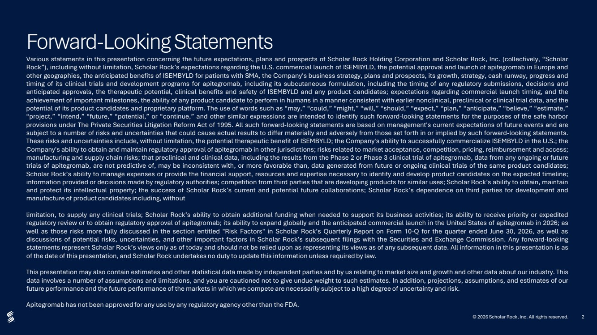 | 2 Forward-Looking Statements Various statements in this presentation concerning the future expectations, plans and prospects of Scholar Rock Holding Corporation and Scholar Rock, Inc. (collectively, “Scholar Rock”), including without limitation, Scholar Rock’s expectations regarding the U.S. commercial launch of ISEMBYLD, the potential approval and launch of apitegromab in Europe and other geographies, the anticipated benefits of ISEMBYLD for patients with SMA, the Company's business strategy, plans and prospects, its growth, strategy, cash runway, progress and timing of its clinical trials and development programs for apitegromab, including its subcutaneous formulation, including the timing of any regulatory submissions, decisions and anticipated approvals, the therapeutic potential, clinical benefits and safety of ISEMBYLD and any product candidates; expectations regarding commercial launch timing, and the achievement of important milestones, the ability of any product candidate to perform in humans in a manner consistent with earlier nonclinical, preclinical or clinical trial data, and the potential of its product candidates and proprietary platform. The use of words such as “may,” “could,” “might,” “will,” “should,” “expect,” “plan,” “anticipate,” “believe,” “estimate,” “project,” “intend,” “future,” “potential,” or “continue,” and other similar expressions are intended to identify such forward-looking statements for the purposes of the safe harbor provisions under The Private Securities Litigation Reform Act of 1995. All such forward-looking statements are based on management's current expectations of future events and are subject to a number of risks and uncertainties that could cause actual results to differ materially and adversely from those set forth in or implied by such forward-looking statements. These risks and uncertainties include, without limitation, the potential therapeutic benefit of ISEMBYLD; the Company's ability to successfully commercialize ISEMBYLD in the U.S.; the Company's ability to obtain and maintain regulatory approval of apitegromab in other jurisdictions; risks related to market acceptance, competition, pricing, reimbursement and access; manufacturing and supply chain risks; that preclinical and clinical data, including the results from the Phase 2 or Phase 3 clinical trial of apitegromab, data from any ongoing or future trials of apitegromab, are not predictive of, may be inconsistent with, or more favorable than, data generated from future or ongoing clinical trials of the same product candidates; Scholar Rock’s ability to manage expenses or provide the financial support, resources and expertise necessary to identify and develop product candidates on the expected timeline; information provided or decisions made by regulatory authorities; competition from third parties that are developing products for similar uses; Scholar Rock’s ability to obtain, maintain and protect its intellectual property; the success of Scholar Rock’s current and potential future collaborations; Scholar Rock’s dependence on third parties for development and manufacture of product candidates including, without limitation, to supply any clinical trials; Scholar Rock’s ability to obtain additional funding when needed to support its business activities; its ability to receive priority or expedited regulatory review or to obtain regulatory approval of apitegromab; its ability to expand globally and the anticipated commercial launch in the United States of apitegromab in 2026; as well as those risks more fully discussed in the section entitled "Risk Factors" in Scholar Rock’s Quarterly Report on Form 10-Q for the quarter ended June 30, 2026, as well as discussions of potential risks, uncertainties, and other important factors in Scholar Rock’s subsequent filings with the Securities and Exchange Commission. Any forward-looking statements represent Scholar Rock’s views only as of today and should not be relied upon as representing its views as of any subsequent date. All information in this presentation is as of the date of this presentation, and Scholar Rock undertakes no duty to update this information unless required by law. This presentation may also contain estimates and other statistical data made by independent parties and by us relating to market size and growth and other data about our industry. This data involves a number of assumptions and limitations, and you are cautioned not to give undue weight to such estimates. In addition, projections, assumptions, and estimates of our future performance and the future performance of the markets in which we compete are necessarily subject to a high degree of uncertainty and risk. Apitegromab has not been approved for any use by any regulatory agency other than the FDA. © 2026 Scholar Rock, Inc. All rights reserved.
 | 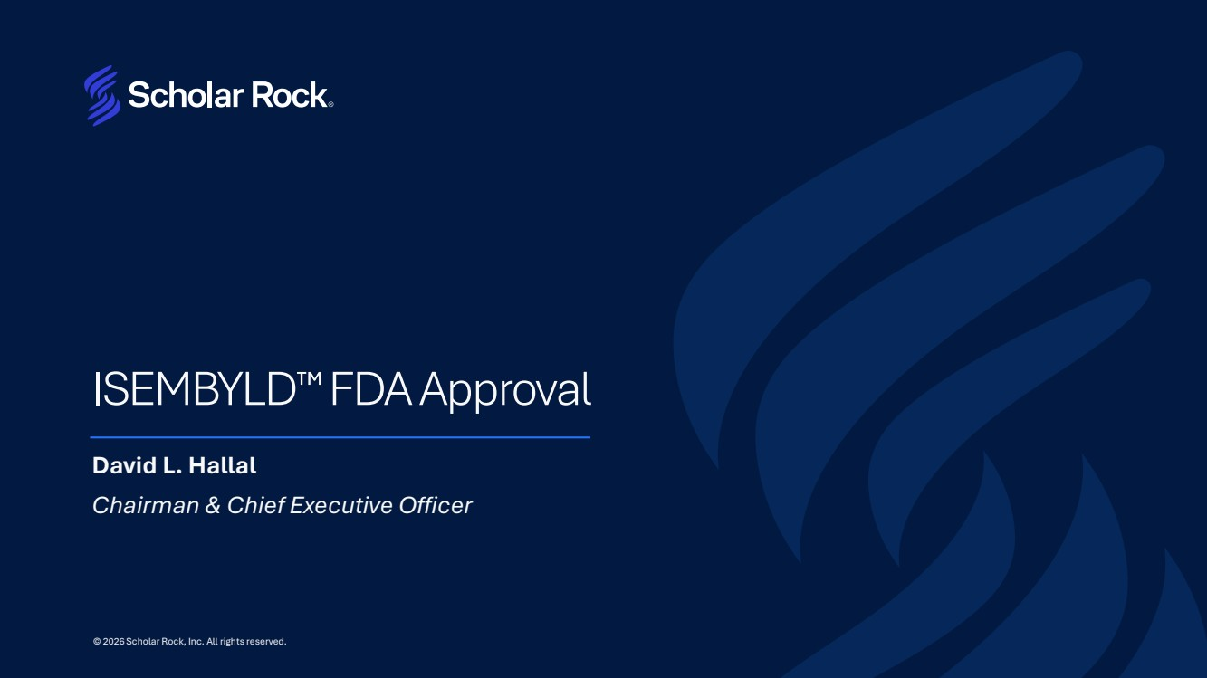 | ISEMBYLD FDA Approval David L. Hallal Chairman & Chief Executive Officer © 2026 Scholar Rock, Inc. All rights reserved.
 | 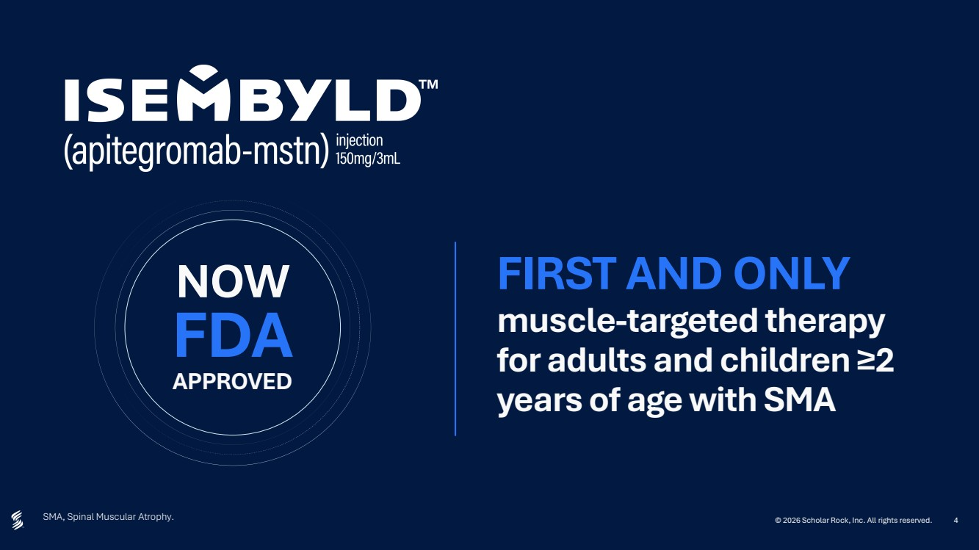 | 4 SMA, Spinal Muscular Atrophy. FIRST AND ONLY muscle-targeted therapy for adults and children ≥2 years of age with SMA FDA APPROVED NOW © 2026 Scholar Rock, Inc. All rights reserved.
 | 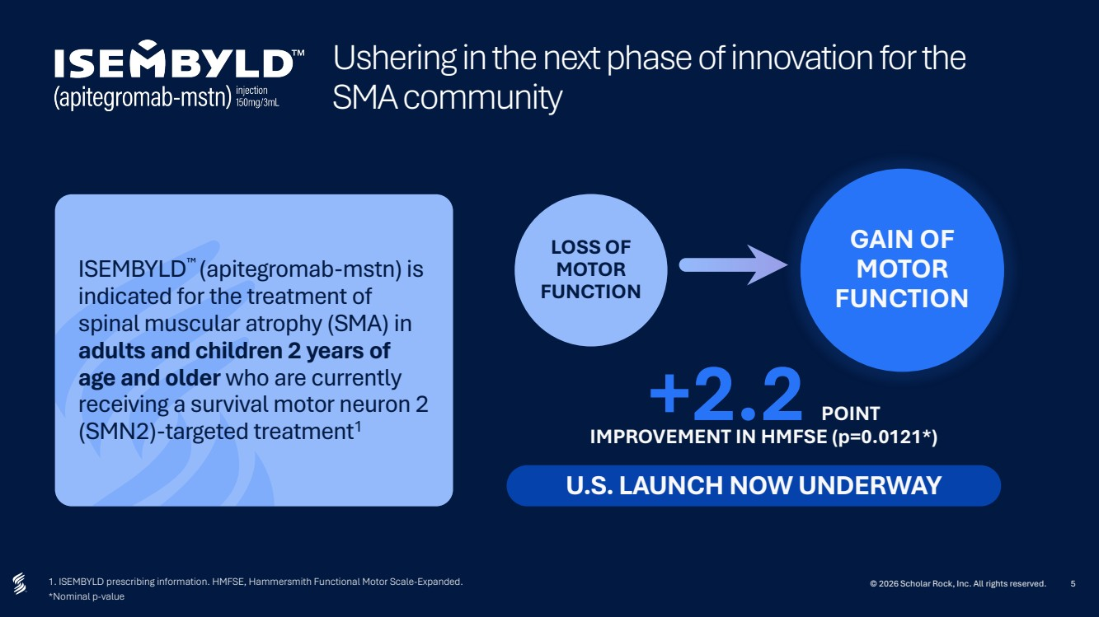 | 5 Ushering in the next phase of innovation for the SMA community 1. ISEMBYLD prescribing information. HMFSE, Hammersmith Functional Motor Scale-Expanded. *Nominal p-value ISEMBYLD (apitegromab-mstn) is indicated for the treatment of spinal muscular atrophy (SMA) in adults and children 2 years of age and older who are currently receiving a survival motor neuron 2 (SMN2)-targeted treatment1 U.S. LAUNCH NOW UNDERWAY LOSS OF MOTOR FUNCTION GAIN OF MOTOR FUNCTION +2.2 POINT IMPROVEMENT IN HMFSE (p=0.0121*) © 2026 Scholar Rock, Inc. All rights reserved.
 | 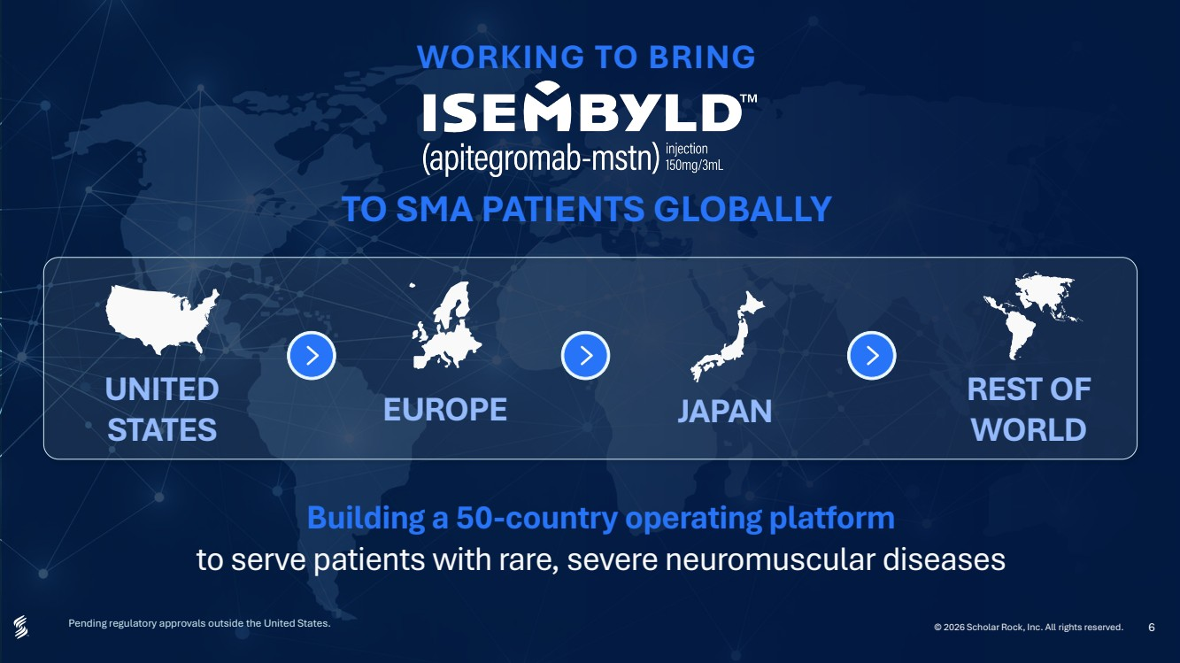 | 6 WORKING TO BRING TO SMA PATIENTS GLOBALLY Building a 50-country operating platform to serve patients with rare, severe neuromuscular diseases UNITED STATES EUROPE REST OF WORLD Pending regulatory approvals outside the United States. © 2026 Scholar Rock, Inc. All rights reserved. 6 JAPAN
 | 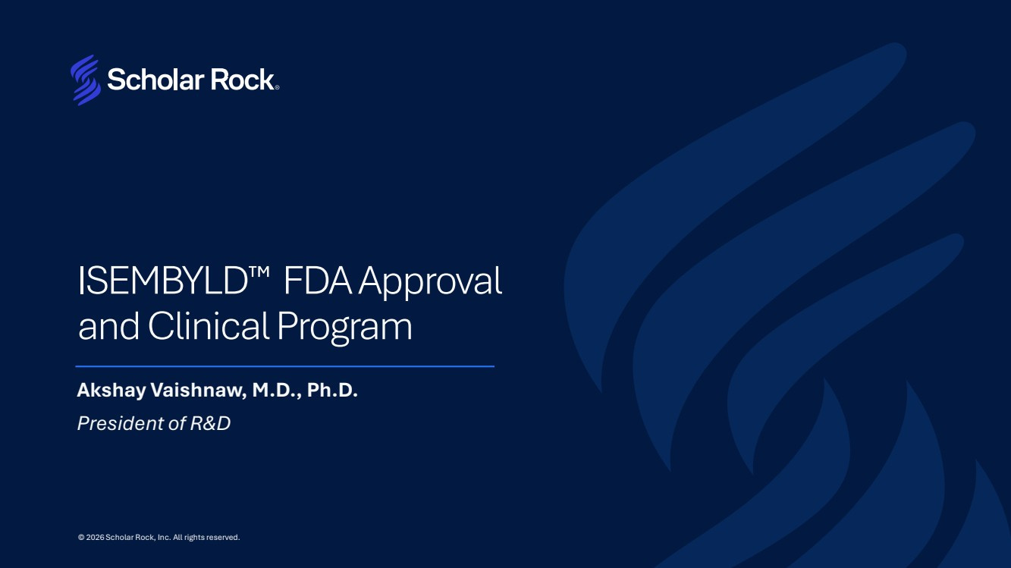 | ISEMBYLD FDA Approval and Clinical Program Akshay Vaishnaw, M.D., Ph.D. President of R&D © 2026 Scholar Rock, Inc. All rights reserved.
 | 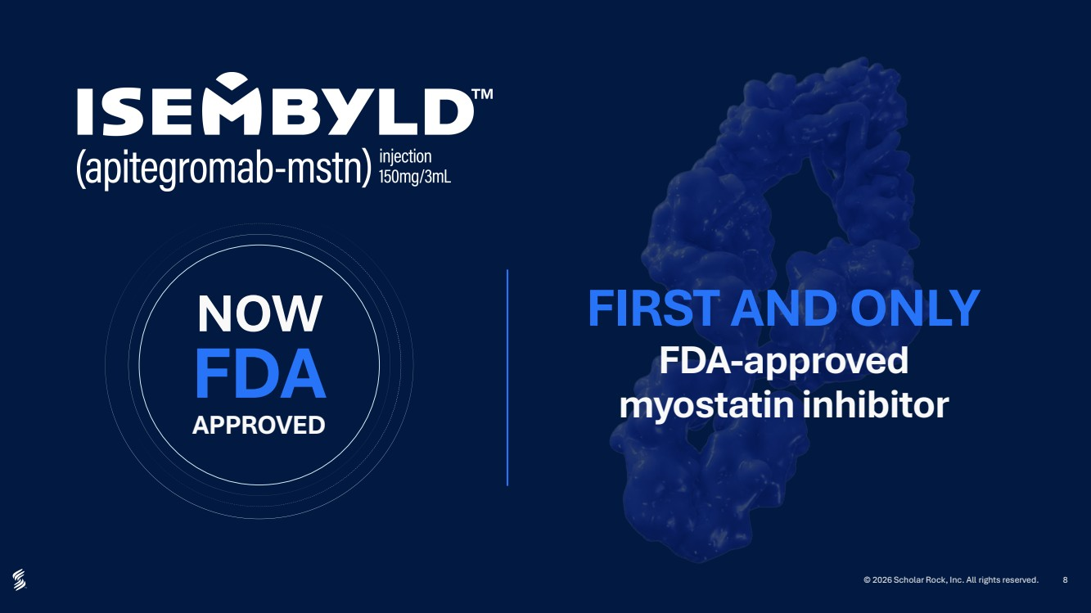 | 8 FIRST AND ONLY FDA-approved myostatin inhibitor FDA APPROVED NOW © 2026 Scholar Rock, Inc. All rights reserved.
 | 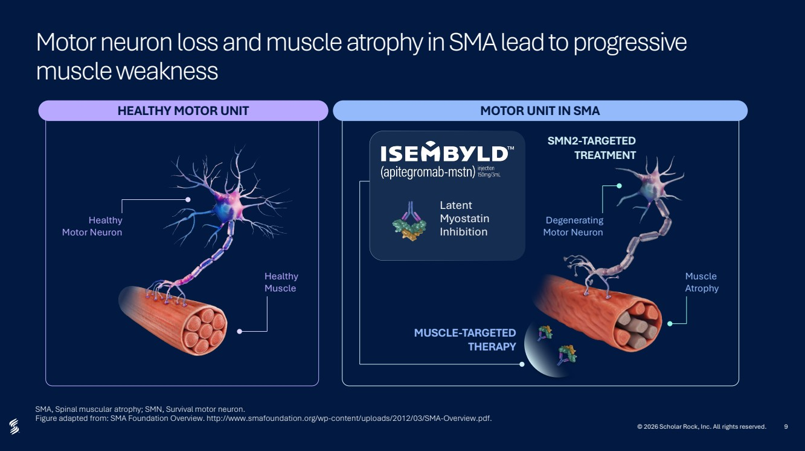 | 9 Motor neuron loss and muscle atrophy in SMA lead to progressive muscle weakness SMA, Spinal muscular atrophy; SMN, Survival motor neuron. Figure adapted from: SMA Foundation Overview. http://www.smafoundation.org/wp-content/uploads/2012/03/SMA-Overview.pdf. HEALTHY MOTOR UNIT MOTOR UNIT IN SMA Healthy Motor Neuron Latent Myostatin Inhibition SMN2-TARGETED TREATMENT MUSCLE-TARGETED THERAPY Degenerating Motor Neuron Muscle Atrophy Healthy Muscle © 2026 Scholar Rock, Inc. All rights reserved.
 | 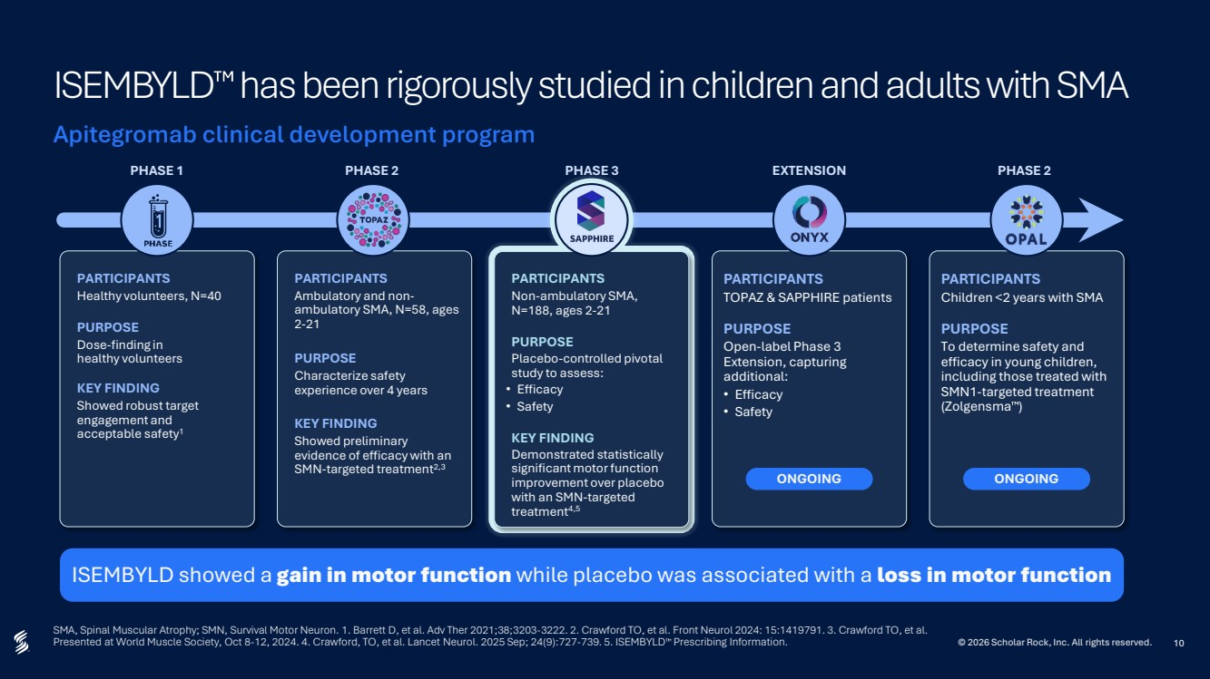 | 10 SMA, Spinal Muscular Atrophy; SMN, Survival Motor Neuron. 1. Barrett D, et al. Adv Ther 2021;38;3203-3222. 2. Crawford TO, et al. Front Neurol 2024: 15:1419791. 3. Crawford TO, et al. Presented at World Muscle Society, Oct 8-12, 2024. 4. Crawford, TO, et al. Lancet Neurol. 2025 Sep; 24(9):727-739. 5. ISEMBYLD Prescribing Information. ISEMBYLD has been rigorously studied in children and adults with SMA Apitegromab clinical development program ISEMBYLD showed a gain in motor function while placebo was associated with a loss in motor function PARTICIPANTS Healthy volunteers, N=40 PURPOSE Dose-finding in healthy volunteers KEY FINDING Showed robust target engagement and acceptable safety1 PARTICIPANTS Ambulatory and non-ambulatory SMA, N=58, ages 2-21 PURPOSE Characterize safety experience over 4 years KEY FINDING Showed preliminary evidence of efficacy with an SMN-targeted treatment2,3 PARTICIPANTS Non-ambulatory SMA, N=188, ages 2-21 PURPOSE Placebo-controlled pivotal study to assess: • Efficacy • Safety KEY FINDING Demonstrated statistically significant motor function improvement over placebo with an SMN-targeted treatment4,5 PARTICIPANTS TOPAZ & SAPPHIRE patients PURPOSE Open-label Phase 3 Extension, capturing additional: • Efficacy • Safety ONGOING PARTICIPANTS Children <2 years with SMA PURPOSE To determine safety and efficacy in young children, including those treated with SMN1-targeted treatment (Zolgensma ) ONGOING PHASE 1 PHASE 2 PHASE 3 EXTENSION PHASE 2 © 2026 Scholar Rock, Inc. All rights reserved.
 | 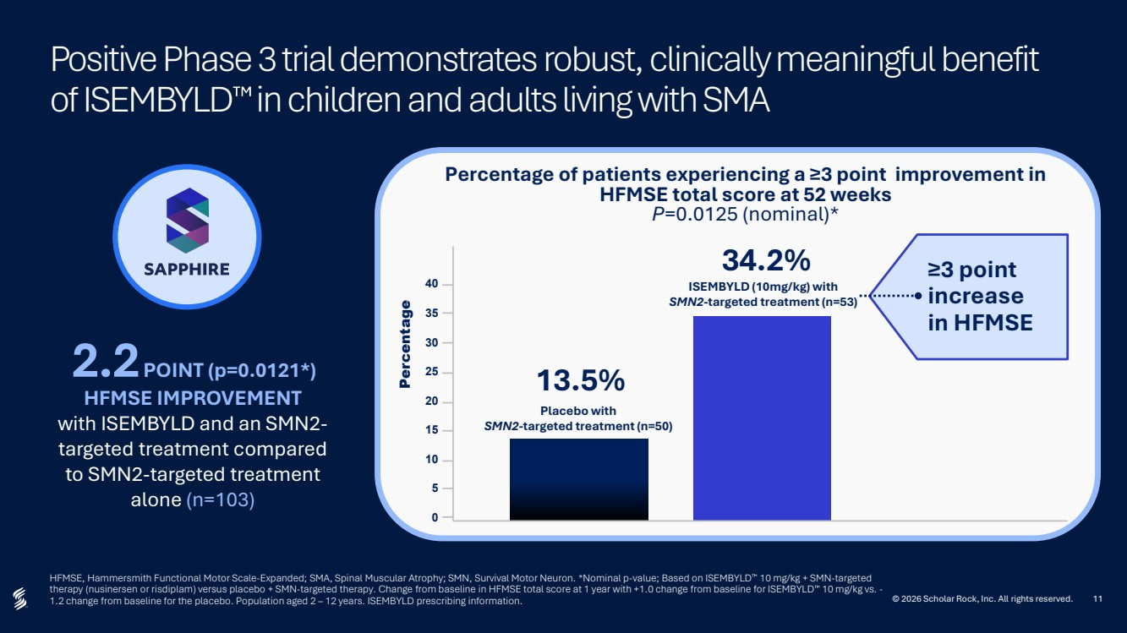 | 11 Positive Phase 3 trial demonstrates robust, clinically meaningful benefit of ISEMBYLD in children and adults living with SMA HFMSE, Hammersmith Functional Motor Scale-Expanded; SMA, Spinal Muscular Atrophy; SMN, Survival Motor Neuron. *Nominal p-value; Based on ISEMBYLD 10 mg/kg + SMN-targeted therapy (nusinersen or risdiplam) versus placebo + SMN-targeted therapy. Change from baseline in HFMSE total score at 1 year with +1.0 change from baseline for ISEMBYLD 10 mg/kg vs. - 1.2 change from baseline for the placebo. Population aged 2 – 12 years. ISEMBYLD prescribing information. © 2026 Scholar Rock, Inc. All rights reserved. Percentage of patients experiencing a ≥3 point improvement in HFMSE total score at 52 weeks P=0.0125 (nominal)* Placebo with SMN2-targeted treatment (n=50) 13.5% ISEMBYLD (10mg/kg) with SMN2-targeted treatment (n=53) 34.2% Percentage ≥3 point increase in HFMSE 40 35 30 25 20 15 10 5 0 HFMSE IMPROVEMENT with ISEMBYLD and an SMN2- targeted treatment compared to SMN2-targeted treatment alone (n=103) 2.2 POINT (p=0.0121*)
 | 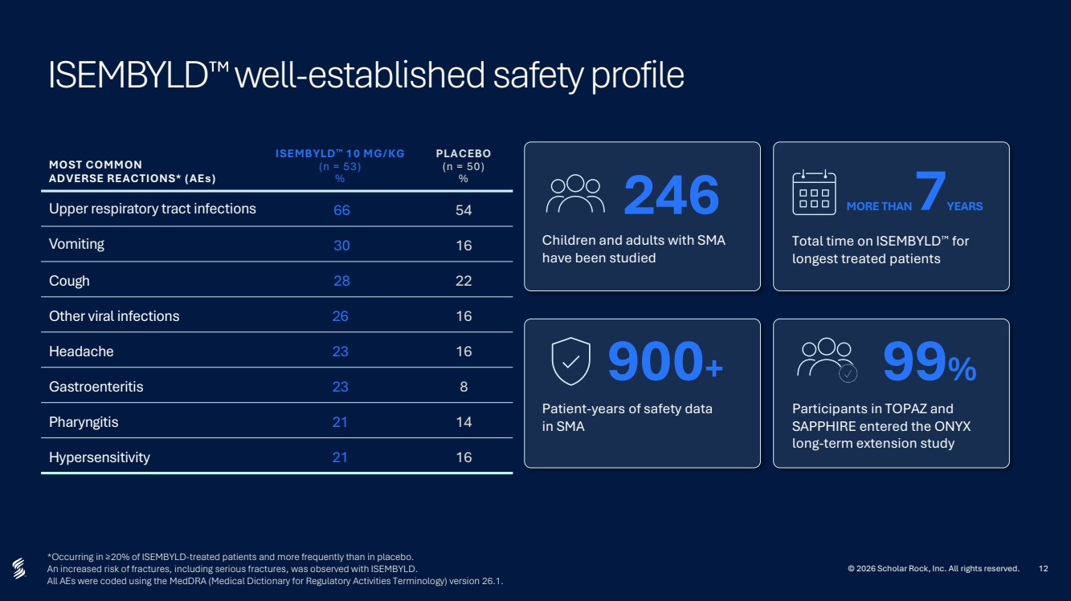 | 12 *Occurring in ≥20% of ISEMBYLD-treated patients and more frequently than in placebo. An increased risk of fractures, including serious fractures, was observed with ISEMBYLD. All AEs were coded using the MedDRA (Medical Dictionary for Regulatory Activities Terminology) version 26.1. ISEMBYLD well-established safety profile MOST COMMON ADVERSE REACTIONS* (AEs) ISEMBYLD 10 MG/KG (n = 53) % PLACEBO (n = 50) % Upper respiratory tract infections 66 54 Vomiting 30 16 Cough 28 22 Other viral infections 26 16 Headache 23 16 Gastroenteritis 23 8 Pharyngitis 21 14 Hypersensitivity 21 16 Children and adults with SMA have been studied 246 Total time on ISEMBYLD for longest treated patients MORE THAN 7YEARS Patient-years of safety data in SMA 900+ Participants in TOPAZ and SAPPHIRE entered the ONYX long-term extension study 99% © 2026 Scholar Rock, Inc. All rights reserved.
 | 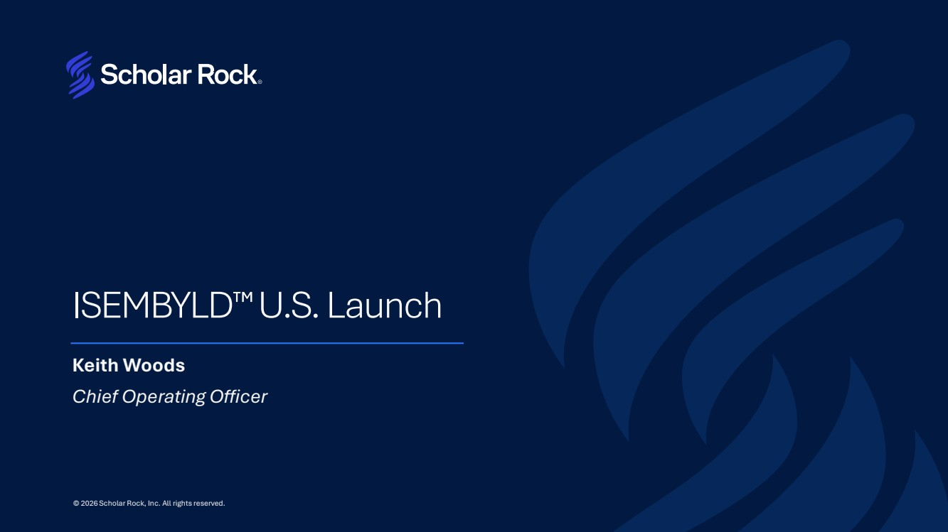 | ISEMBYLD U.S. Launch Keith Woods Chief Operating Officer © 2026 Scholar Rock, Inc. All rights reserved.
 | 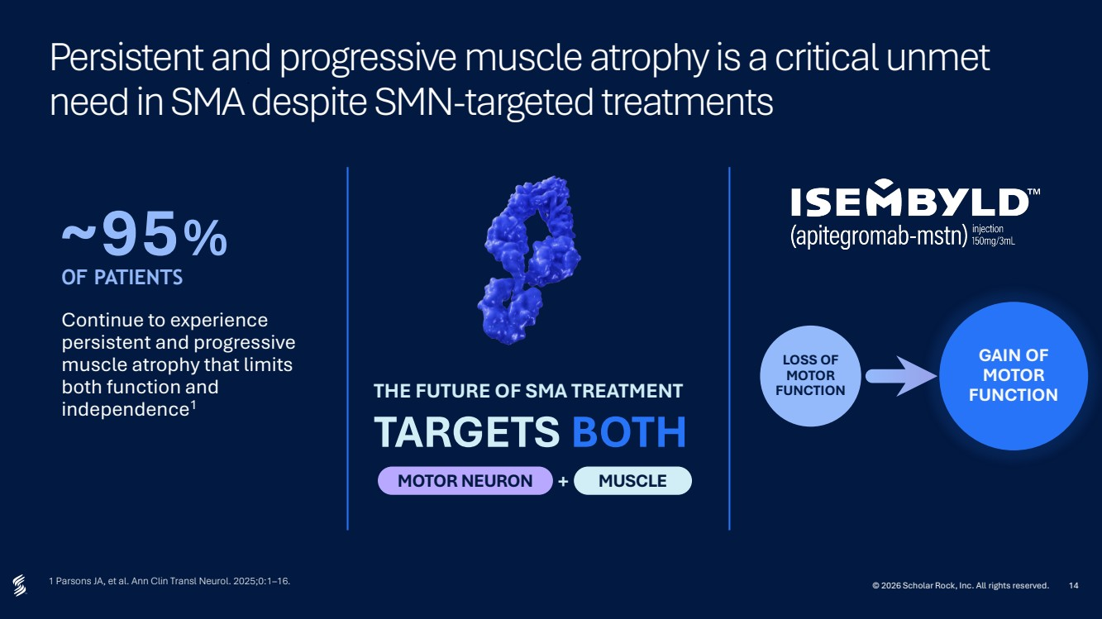 | 14 Persistent and progressive muscle atrophy is a critical unmet need in SMA despite SMN-targeted treatments 1 Parsons JA, et al. Ann Clin Transl Neurol. 2025;0:1–16. © 2026 Scholar Rock, Inc. All rights reserved. Continue to experience persistent and progressive muscle atrophy that limits both function and independence1 ~95% OF PATIENTS THE FUTURE OF SMA TREATMENT TARGETS BOTH MOTOR NEURON + MUSCLE LOSS OF MOTOR FUNCTION GAIN OF MOTOR FUNCTION
 | 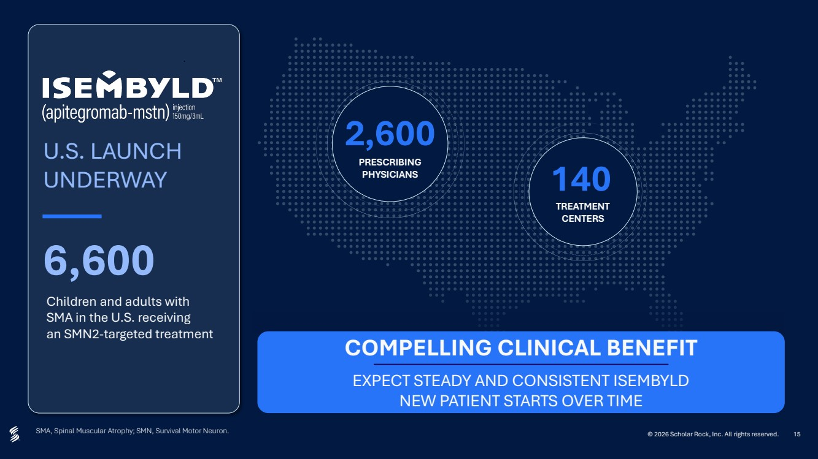 | 15 SMA, Spinal Muscular Atrophy; SMN, Survival Motor Neuron. © 2026 Scholar Rock, Inc. All rights reserved. U.S. LAUNCH UNDERWAY 6,600 Children and adults with SMA in the U.S. receiving an SMN2-targeted treatment 2,600 PRESCRIBING PHYSICIANS 140 TREATMENT CENTERS COMPELLING CLINICAL BENEFIT EXPECT STEADY AND CONSISTENT ISEMBYLD NEW PATIENT STARTS OVER TIME
 | 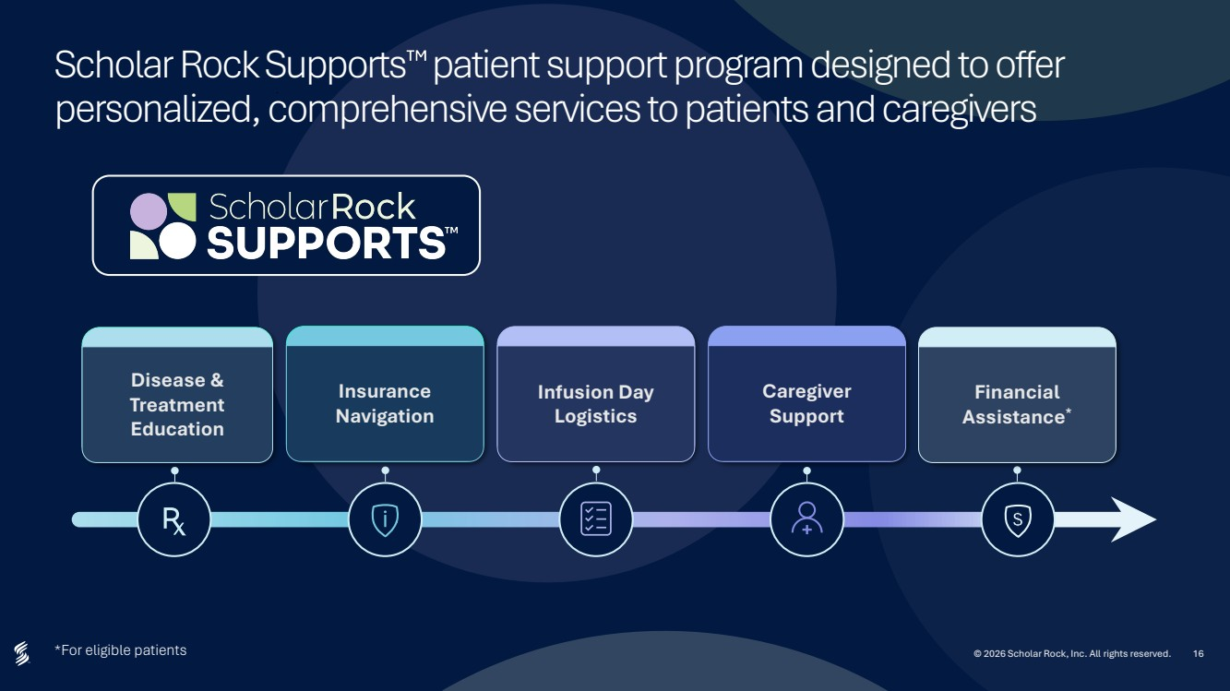 | 16 Scholar Rock Supports patient support program designed to offer personalized, comprehensive services to patients and caregivers *For eligible patients © 2026 Scholar Rock, Inc. All rights reserved. Disease & Treatment Education Insurance Navigation Infusion Day Logistics Caregiver Support Financial Assistance*
 | 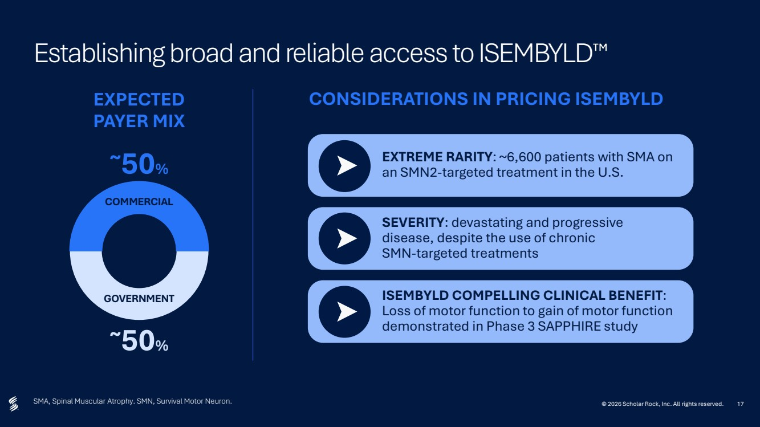 | 17 Establishing broad and reliable access to ISEMBYLD SMA, Spinal Muscular Atrophy. SMN, Survival Motor Neuron. COMMERCIAL GOVERNMENT ~50% ~50% EXTREME RARITY: ~6,600 patients with SMA on an SMN2-targeted treatment in the U.S. SEVERITY: devastating and progressive disease, despite the use of chronic SMN-targeted treatments ISEMBYLD COMPELLING CLINICAL BENEFIT: Loss of motor function to gain of motor function demonstrated in Phase 3 SAPPHIRE study EXPECTED PAYER MIX CONSIDERATIONS IN PRICING ISEMBYLD © 2026 Scholar Rock, Inc. All rights reserved.
 | 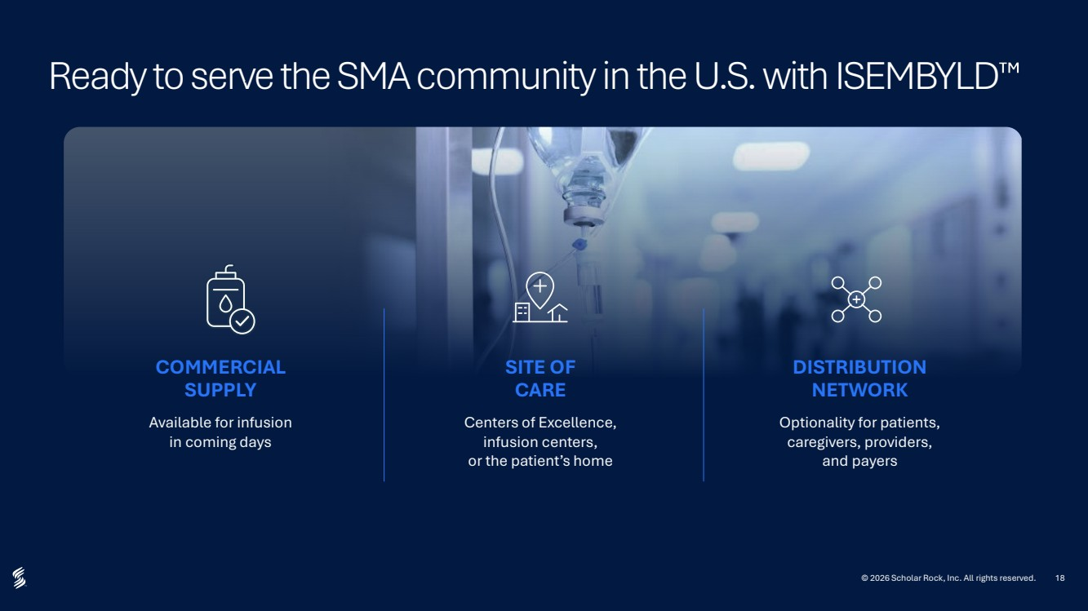 | 18 Ready to serve the SMA community in the U.S. with ISEMBYLD Available for infusion in coming days Centers of Excellence, infusion centers, or the patient’s home COMMERCIAL SUPPLY SITE OF CARE © 2026 Scholar Rock, Inc. All rights reserved. Optionality for patients, caregivers, providers, and payers DISTRIBUTION NETWORK
 |  | Financial Update Vikas Sinha Chief Financial Officer © 2026 Scholar Rock, Inc. All rights reserved.
 | 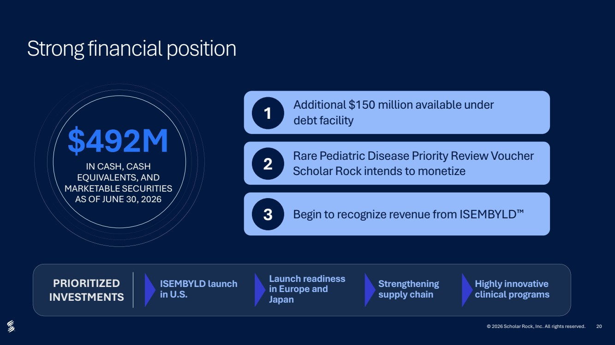 | 20 Strong financial position Additional $150 million available under debt facility 1 Rare Pediatric Disease Priority Review Voucher Scholar Rock intends to monetize 2 3 Begin to recognize revenue from ISEMBYLD $492M IN CASH, CASH EQUIVALENTS, AND MARKETABLE SECURITIES AS OF JUNE 30, 2026 PRIORITIZED INVESTMENTS © 2026 Scholar Rock, Inc. All rights reserved. ISEMBYLD launch in U.S. Strengthening supply chain Launch readiness in Europe and Japan Highly innovative clinical programs
 | 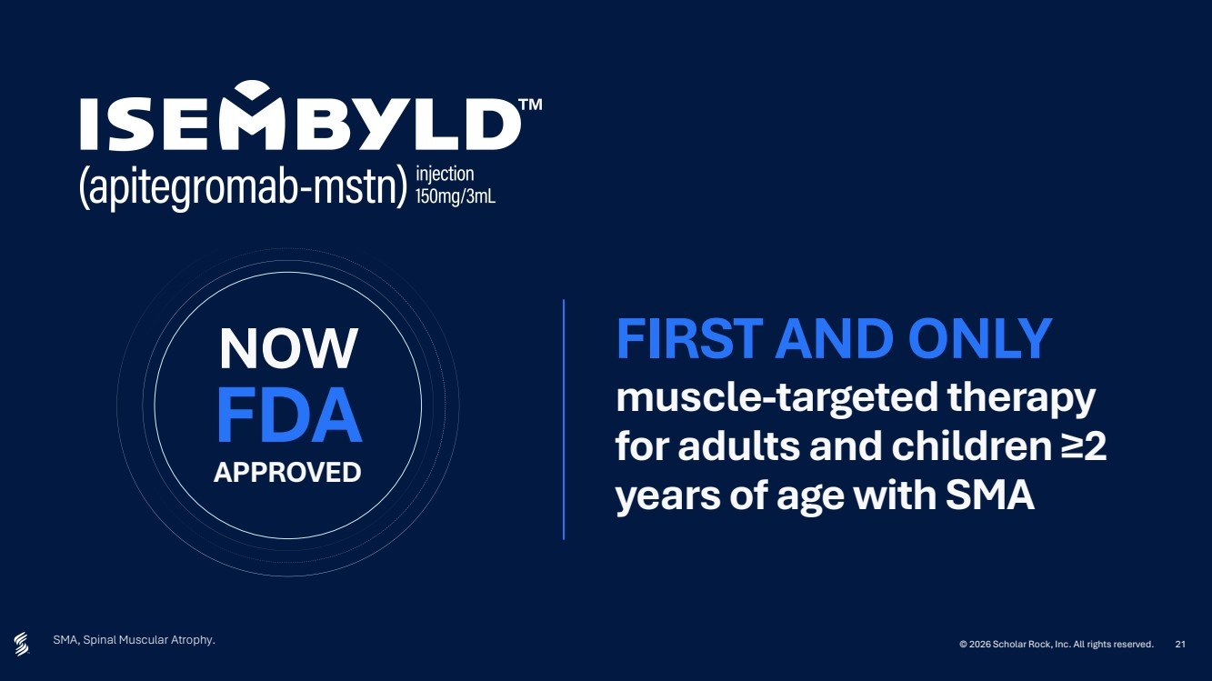 | 21 SMA, Spinal Muscular Atrophy. FIRST AND ONLY muscle-targeted therapy for adults and children ≥2 years of age with SMA FDA APPROVED NOW © 2026 Scholar Rock, Inc. All rights reserved.
 |  | ir@scholarrock.com media@scholarrock.com www.scholarrock.com THANK YOU © 2026 Scholar Rock, Inc. All rights reserved.

